Java OOPs Concepts->

*Object means a real word entity such as pen, chair, table etc.

* Object-Oriented Programming is a methodology or paradigm to design a program using classes and objects.

* It simplifies the software development and maintenance by providing some concepts:

* Object
* Class
* Inheritance
* Polymorphism
* Abstraction
* Encapsulation

1.object-> a object is a entity which implement the class.and its requires space .

2. class-> *class is a collection of data members and data function.its also a collection of objects.

*blueprint of an object.

3.inheritance->it implements the reusability of an properties of another class to any class.

4.polymorphism->*When **one task is performed by different ways** .

*i.e. known as polymorphism. For example: to convince the customer differently, to draw something e.g. shape or rectangle etc.

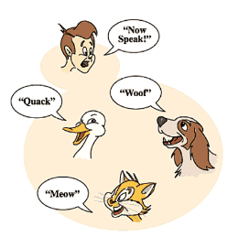

#### 5. **Abstraction->Hiding internal details and showing functionality is known as abstraction. For example: phone call, we don't know the internal processing.**

#### **6. encapsulation->Binding (or wrapping) code and data together into a single unit is known as encapsulation. For example: capsule, it is wrapped with different medicines.**

Object based programing language->

*Object based programming language follows all the features of OOPs except Inheritance.

* JavaScript and VBScript are examples of object based programming languages.

Java Naming Conventions->

*By using standard Java naming conventions, you make your code easier to read for yourself and for other programmers. Readability of Java program is very important. It indicates that **less time,**

